MINI PROJECT REPORT

A Mini Project Report submitted
In the Partial of Fulfillment of the Requirements for
OOP-Lab


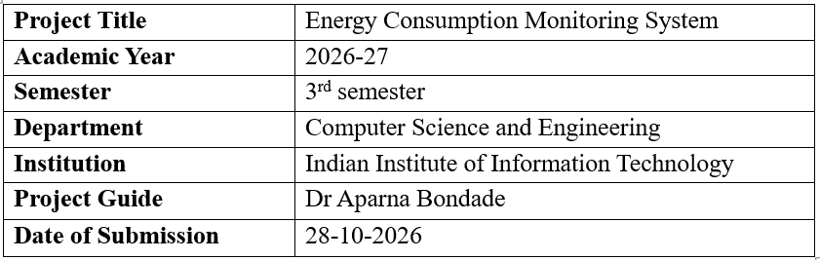
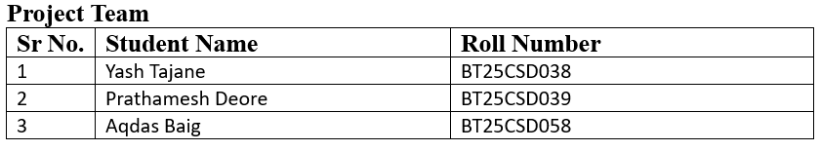

1. Introduction and Overview
Electricity is one of the major recurring expenses for homes, hostels, and small offices. With the increasing use of electrical appliances such as fans, lights, refrigerators, and computers, monitoring energy consumption has become important for managing expenses and reducing unnecessary energy wastage. However, manually maintaining electricity consumption records can be time-consuming and prone to errors. The absence of an organized record also makes it difficult to identify high-consumption devices and estimate electricity expenses in advance.The Energy Consumption Monitoring System is a menu-driven console application developed in C++ using Object-Oriented Programming (OOP) concepts. It provides a simple and systematic way to maintain electricity consumption records for different devices. Each record contains a unique ID, device name, date, and units consumed in kilowatt-hours (kWh). The application allows users to add new records, view all records, search by ID, device name or date, update existing information, and delete records when required.
To ensure that the information remains available for future use, the system uses file handling to store records permanently in a text file. Previously saved records are loaded whenever the program starts, allowing users to continue managing their data without entering it again. The application also includes input validation to reduce errors by checking device names, date formats, and consumption values before accepting the data.The system provides an analysis feature that calculates total and average electricity consumption and identifies the highest and lowest consumption records. It also estimates the electricity bill using a slab-based tariff structure, where the first 100 units are charged at ₹3 per unit, the next 200 units at ₹5 per unit, and units above 300 at ₹8 per unit. This helps users understand their overall consumption and obtain an approximate estimate of their electricity expenses.
Overall, the project combines record management, data analysis, file handling, and bill estimation in a single application. It demonstrates the practical use of C++ concepts such as classes, objects, encapsulation, constructors, vectors, and file input/output operations. The system aims to make electricity consumption tracking more organized and convenient while helping users understand their energy usage patterns and manage their expenses effectively.
Problem Statement
The objective is to design and implement an object-oriented program that maintains a persistent log of device-wise energy consumption, supports full record management (create, read, search, update, and delete), validates user input, and generates a summary with an estimated electricity bill. The system should ensure that records remain available across program executions through file handling and maintain data consistency by preventing invalid entries. It should also analyse consumption patterns by calculating total, average, highest, and lowest energy consumption. The application aims to provide a simple and reliable way to manage electricity usage records and estimate expenses based on a slab-based tariff structure.
Key Features
• Add, view, search (by ID, device name or date), update and delete consumption records
• Automatic ID generation for every new record
• Persistent storage in energy_data.txt; data is reloaded when the program starts • Strict input validation for text, dates (DD-MM-YYYY) and units (non-negative numbers)
• Data analysis: total, average, highest and lowest consumption • Slab-based electricity bill estimation (Rs.3 / Rs.5 / Rs.8 per unit)
• Confirmation prompt before deleting a record
Objectives
• Apply core OOP principles (classes, objects, encapsulation, abstraction, constructors, composition) to a practical problem.
• Implement file handling so that data survives between program runs.
• Build a robust console interface that never crashes on wrong input.
• Provide meaningful analysis so that users can identify high-consumption devices and estimate cost.
Scope
The system is intended for single-user, offline use on a desktop or laptop. It works on manually entered readings (it does not connect to smart meters) and uses a fixed, hard-coded tariff. The design is deliberately modular so that a GUI, database or configurable tariff can be added later.

2.Methodology and System Design
Requirements
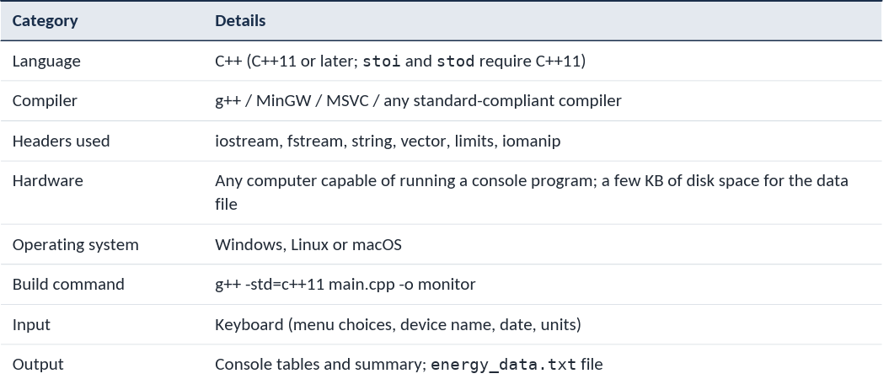

Development Phases
The project followed a simple, incremental development approach: requirement analysis, object-oriented design, implementation, validation and testing. The main design decisions are described below.
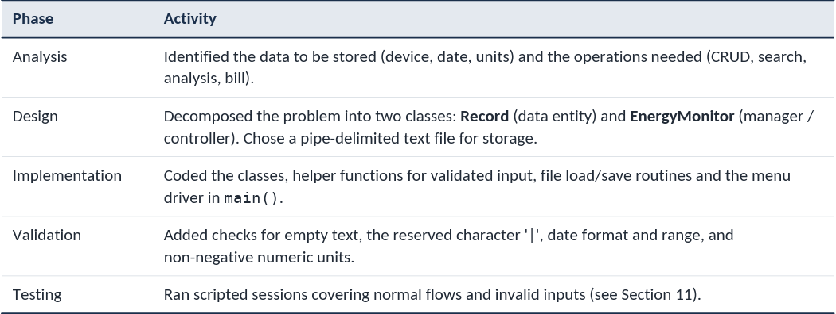
System Architecture
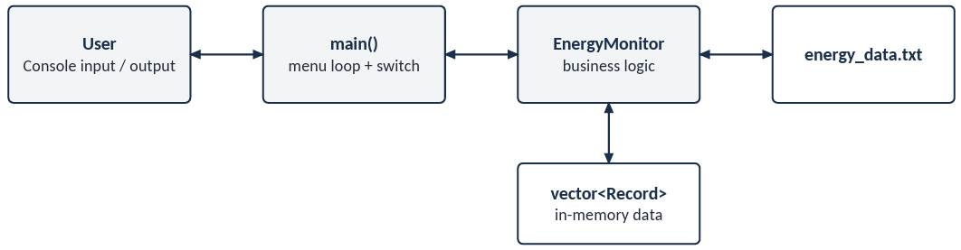
The user interacts only with the menu in main(). Each menu option calls one public method of a single EnergyMonitor object, which owns a vector<Record> in memory and synchronises it with the text file.
Program Flow
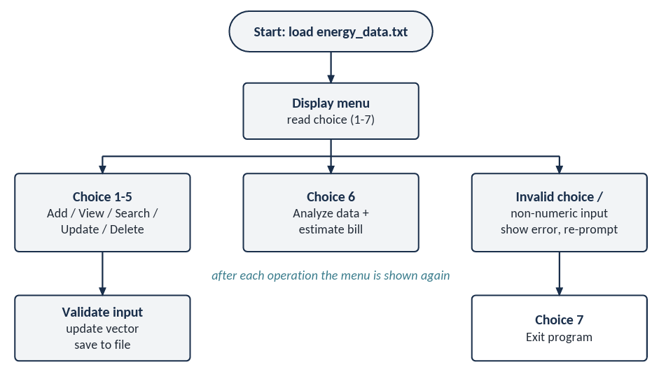
Key Design Decisions
• Write-through persistence: after every add, update or delete, saveToFile() rewrites the file, so no data is lost if the program is closed abruptly.
• Auto-increment ID: getNextId() returns (largest existing ID + 1), so the user never has to type or manage IDs.
• Validated input loops: helper functions readText, readDate and readUnits keep asking until valid input is given.
• Buffer handling: after every numeric read, cin.ignore(numeric_limits<streamsize>::max(), '\n') clears leftover characters so that later getline calls work correctly.
• Corruption tolerance: lines in the data file that are malformed are skipped during loading instead of crashing the program.
Bill Calculation Algorithm
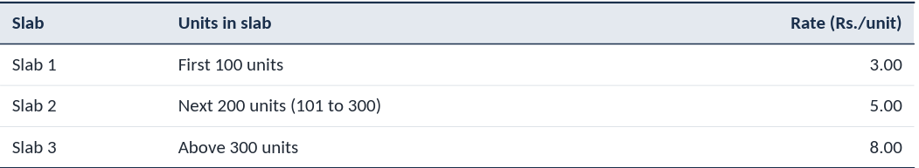
Worked example (total = 295.5 kWh): Slab 1 = 100 x 3 = 300.00; Slab 2 = 195.5 x 5 = 977.50; Slab 3 = 0. Estimated bill = Rs. 1277.50. This matches the program output shown in Section 10.
The estimated bill is computed with a progressive slab tariff. Units are consumed slab by slab, and each slab is charged at its own rate.
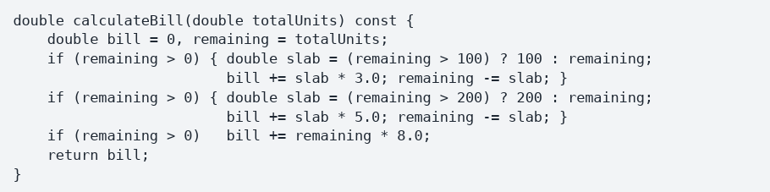

OOP Concepts Applied
The project incorporates several fundamental concepts of Object-Oriented Programming (OOP) and C++ to ensure efficient data management, code reusability, and maintainability. These concepts are applied throughout the program to organize consumption records, handle user operations, validate inputs, and store data persistently. The following table summarizes the key concepts used in the project and their respective implementations.
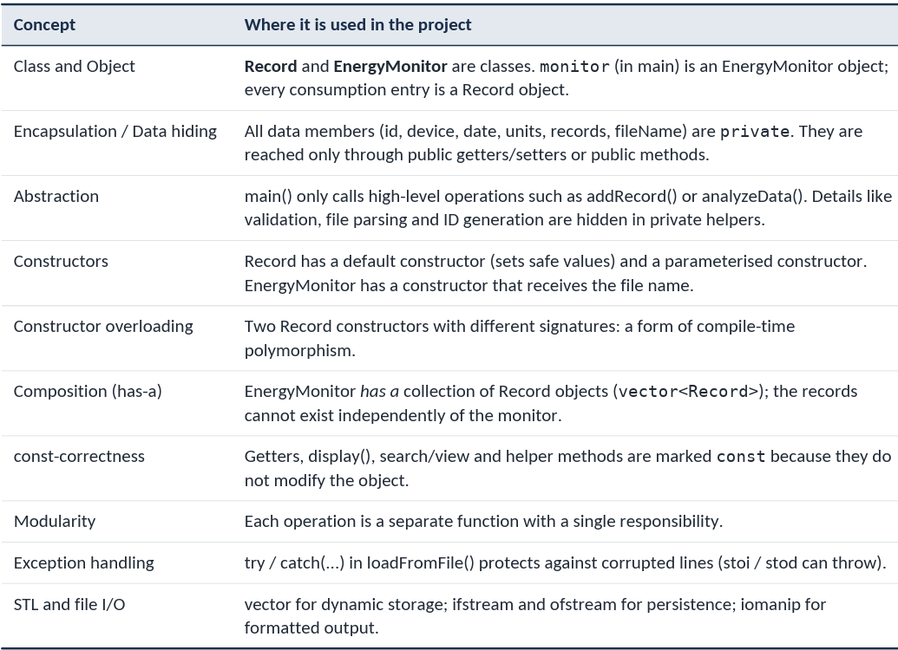
4. Classes and Objects
Class Record
The Record class represents a single energy-consumption entry and stores its ID, device name, date, and units consumed. It uses encapsulation to protect its data and provides constructors, getters, setters, and a display function to initialize, access, update, and present record details. The following table describes its attributes and member functions.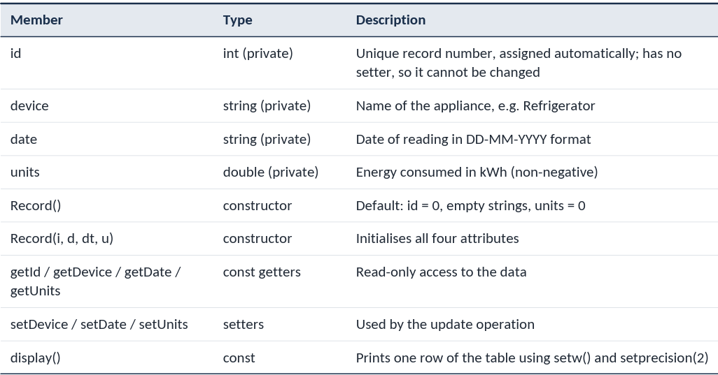
Class EnergyMonitor
The EnergyMonitor class acts as the main controller of the system. It manages all consumption records, handles file storage, validates user input, and performs data analysis and bill estimation. The following table describes its data members and member functions.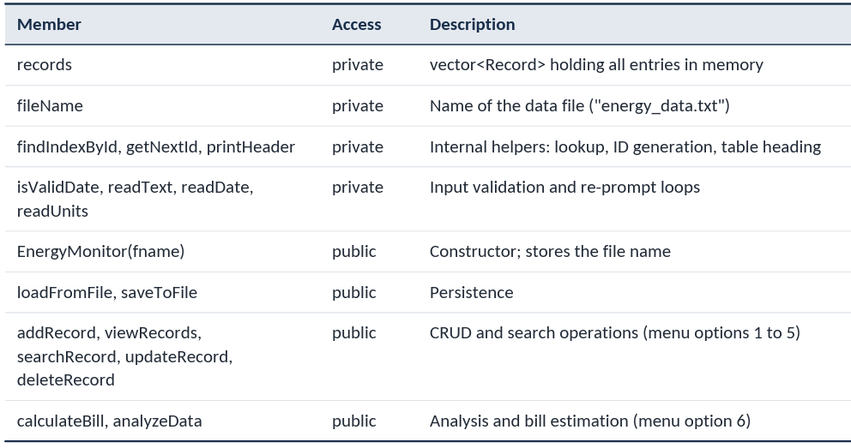
Objects in the Program
The project creates two main types of objects: EnergyMonitor and Record. The EnergyMonitor object manages the application throughout its execution, while Record objects represent individual consumption entries stored in the vector. The following table describes their creation, storage, and lifetime.
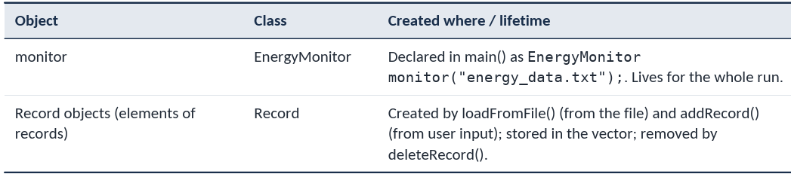

5. Function-wise Code Description
The following table provides a function-wise description of the major functions used in the Energy Consumption Monitoring System. It explains their purpose, working logic, and time complexity for in-memory operations, where \(n\) represents the number of records. This helps illustrate how each function contributes to record management, file handling, input validation, data analysis, and bill estimation.
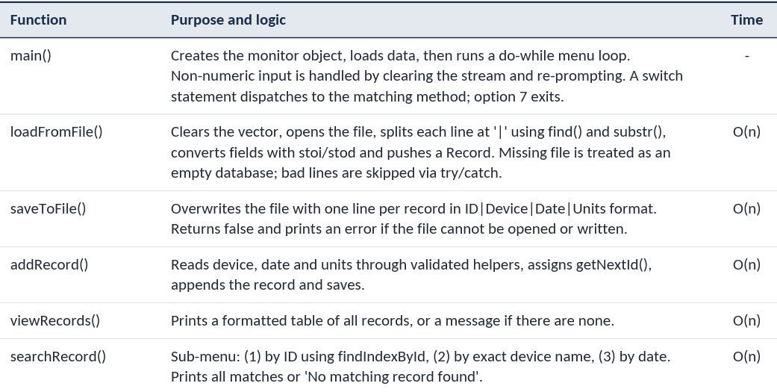
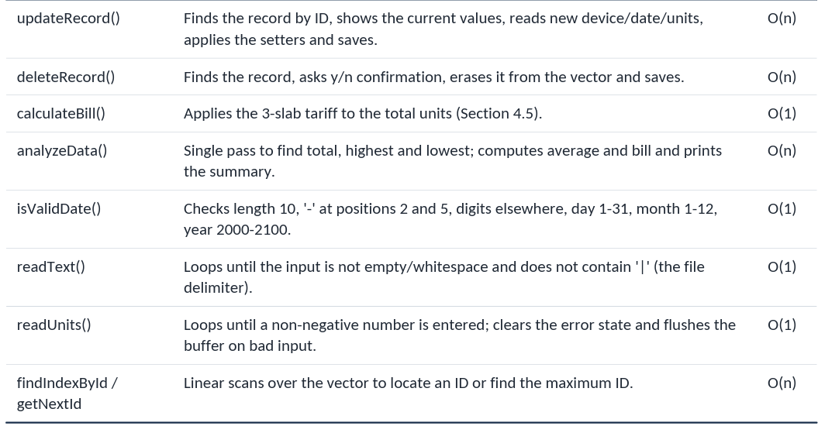

Important Code Snippets and Implementation Details
The following code snippets highlight the important implementation details of the Energy Consumption Monitoring System. They demonstrate the calculation of electricity bills using a slab-based tariff, the analysis of energy consumption records, and the permanent storage of data using file handling.
1. Slab-Based Electricity Bill Calculation
This function calculates the estimated electricity bill by applying different rates to different ranges of units consumed. The first 100 units are charged at ₹3 per unit, the next 200 units at ₹5 per unit, and any remaining units at ₹8 per unit.
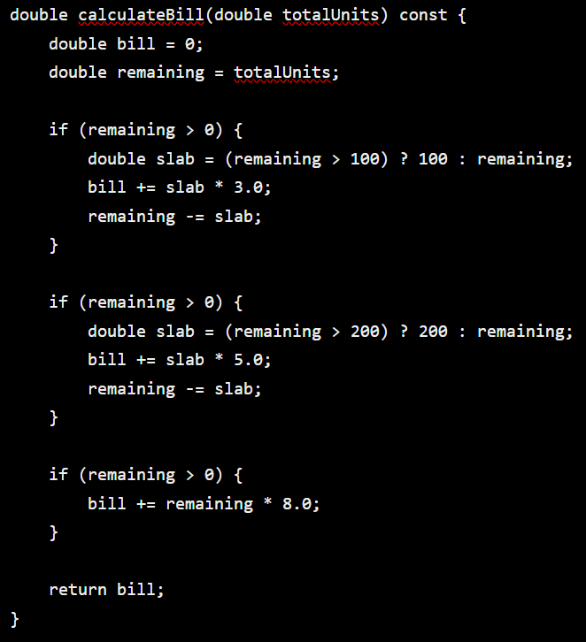

2. Energy Consumption Analysis
This code processes the stored records to calculate total consumption and identify the records with the highest and lowest energy usage. It then calculates the average consumption and estimated bill.
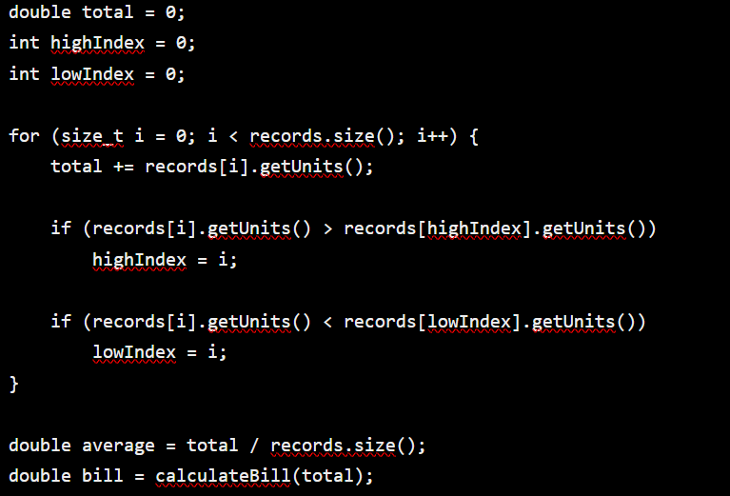
Data Storage Format
The system stores electricity consumption records in a text file named energy_data.txt. Each record occupies one line, and its fields are separated by the pipe (|) character. This format allows the program to save records and load them again when it is restarted. Since the pipe character is used as a delimiter, it is not allowed in device names. Record ID 4 is absent because it was deleted during the demonstration. The remaining records retain their original IDs, as the system does not automatically renumber records after deletion.
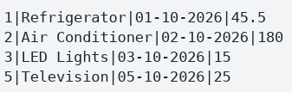

6. Use Cases
The Energy Consumption Monitoring System provides seven use cases accessible through its main menu. These use cases describe the interactions between the user and the system, covering record management, data analysis, bill estimation, and program termination. The following table summarizes the steps involved in each use case and its expected outcome.
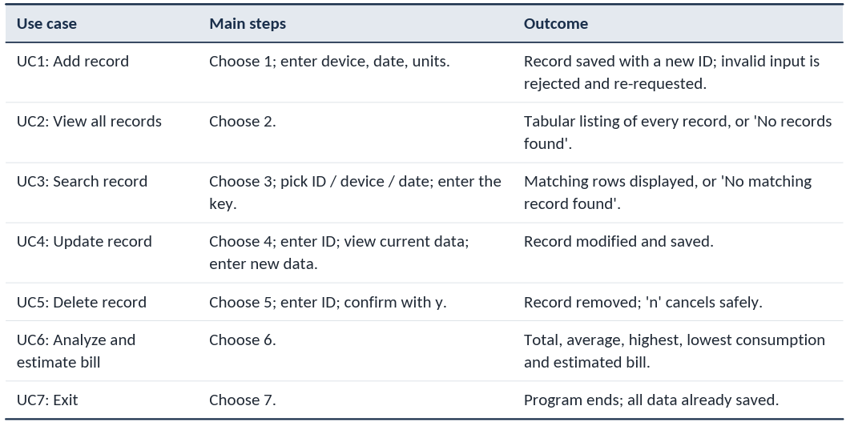

Practical scenarios
• Household: log daily readings for the refrigerator, AC and lights, then use the analysis to see which appliance dominates the bill.
• Hostel / PG: record per-room appliance usage and check the estimated bill before the month ends.
• Energy-saving awareness: compare the highest and lowest consumers and decide where to cut usage.
• Academic demonstration: a compact example of OOP, file handling and input validation in C++.

7. Results and Sample Output
The Energy Consumption Monitoring System was compiled using g++ with C++11 support and executed through a demonstration session. The following outputs illustrate the main features of the application, including adding records, searching by device name, validating user input, analysing energy consumption, estimating electricity bills, and deleting records. The menu text has been omitted for brevity.
Records after adding five devices
Five energy consumption records were added to the system. Each record contains a unique ID, device name, date, and units consumed.
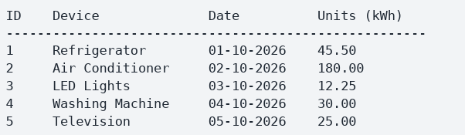
During the addition of the Television record, invalid inputs were deliberately entered to test the validation mechanism. When the date 32-13-2026 was entered, the program displayed Invalid date format. Similarly, entering abc for units resulted in the message Invalid input. Enter a non-negative number. In both cases, the program prompted the user to enter valid information again.
Searching by Device Name
The search functionality was tested by entering the device name Air Conditioner. The system displayed the matching record, including its ID, date, and consumption value.
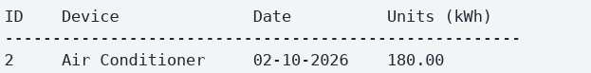
This confirms that the system can retrieve a specific record using the device name without displaying unrelated records.
Data Analysis Before Deletion
The LED Lights consumption was updated from 12.25 kWh to 15.00 kWh. The analysis feature was then used to calculate the total and average consumption, identify the highest and lowest consumption records, and estimate the electricity bill.
The total consumption was 295.50 kWh, and the average consumption per record was 59.10 kWh. The Air Conditioner was identified as the highest-consuming device, while LED Lights had the lowest consumption after the update. Since the total consumption was below 300 units, the estimated bill was calculated using the first two tariff slabs.
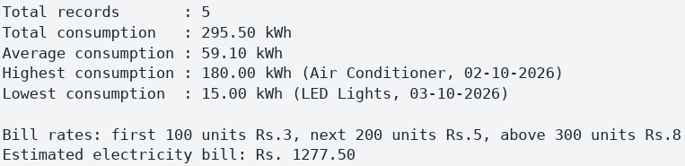
Data Analysis After Deleting a Record
The Washing Machine record (ID 4), which contained 30.00 kWh of consumption, was deleted. The analysis feature was executed again to observe the effect of deletion on the overall consumption and estimated bill.
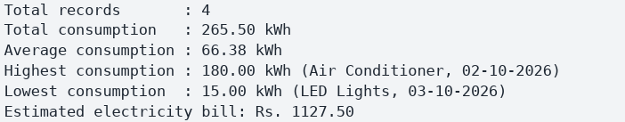
After deletion, the number of records decreased from five to four, and total consumption decreased from 295.50 kWh to 265.50 kWh. The estimated bill also decreased because the deleted record contributed 30 units to the total consumption.
Summary of results
The following table compares the system's results before and after deleting the Washing Machine record.
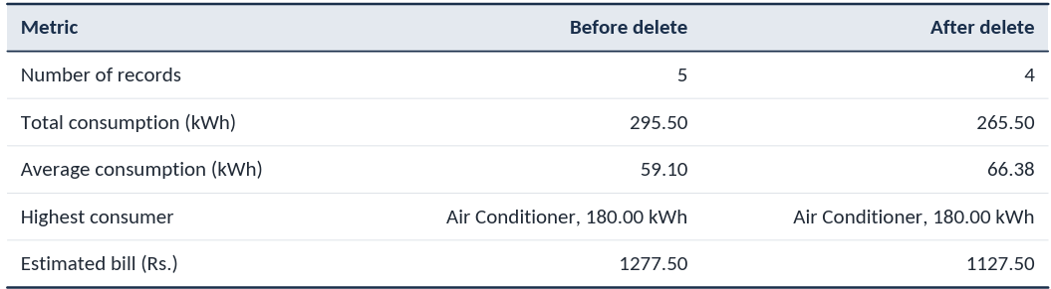
The results show that the Air Conditioner accounted for approximately 60.9% of the total consumption before deletion (180 out of 295.5 kWh), making it the primary energy-consuming device in the demonstration. Deleting the 30 kWh Washing Machine record reduced the estimated bill by Rs. 150. This matches the second tariff slab rate of Rs. 5 per unit because the total consumption remained between 100 and 300 units.
Overall, the demonstration verifies the main functions of the system, including record addition, searching, updating, deletion, input validation, consumption analysis, and slab-based bill estimation. It also demonstrates how the system helps organize energy consumption records and identify devices that contribute most to electricity usage.
8. Testing Summary
The Energy Consumption Monitoring System was tested using different test cases to verify the correctness of its operations and its ability to handle invalid inputs. The tests covered record addition, input validation, searching, updating, deletion, menu selection, file persistence, and electricity bill calculation. The following table summarizes the test cases and their observed results.
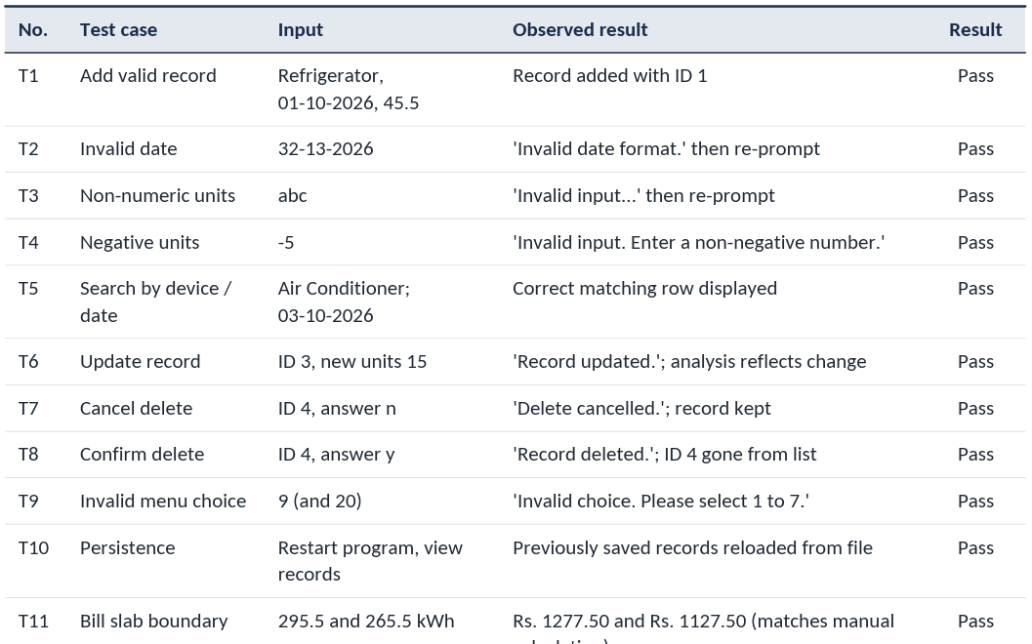

9. Limitations and Future Scope
Current Limitations
Although the Energy Consumption Monitoring System performs its main functions successfully, it has certain limitations:
- Bill calculation: The electricity bill is calculated using the total consumption of all stored records rather than calculating it separately for each month. Therefore, the estimate is most meaningful when the records represent a single billing period.
- Date validation: The program checks the date format and basic ranges for the day, month, and year, but it does not validate the actual number of days in each month or account for leap years. For example, a date such as 31-02-2026 may be accepted.
- Search functionality: Device-name searches require an exact, case-sensitive match, which means differences in capitalization or spelling may prevent a match.
- Record ID management: New IDs are generated using the maximum existing ID plus one. If the record with the highest ID is deleted, its ID may be reused when a new record is added.
- Fixed tariff rates: The electricity tariff rates are hard-coded in the program and cannot be changed through the user interface.
- Data security: Records are stored in a plain-text file without encryption, so the stored information is not protected against unauthorized access.
- Console-based interface: The application uses a text-based menu and does not provide a graphical user interface or visual charts.
Future Scope
The system can be enhanced in several ways to improve its functionality, usability, and flexibility:
- Advanced reporting: Add month-wise and device-wise consumption reports, along with filtering by date range, to provide more detailed analysis.
- Configurable billing: Store tariff rates in a separate settings file and include additional billing components such as fixed charges and taxes.
- Inheritance and runtime polymorphism: Introduce a base class named Appliance with derived classes such as Cooling and Lighting. Virtual functions could be used to implement device-specific consumption calculations or rules.
- Operator overloading and templates: Overload operators such as << to simplify the display of Record objects and use templates where appropriate to support generic data handling.
- Improved date and search handling: Implement calendar-aware date validation, sorting of records, and case-insensitive device-name searches.
- Graphical interface and database support: Develop a graphical user interface, integrate an SQLite database for structured data storage, and display consumption trends through charts.
- Energy-saving recommendations: Analyse consumption patterns and provide suggestions to help users reduce electricity usage and manage expenses more effectively.
These improvements could make the application more flexible, secure, user-friendly, and suitable for managing larger amounts of energy consumption data.

10. Conclusion
The Energy Consumption Monitoring System demonstrates how object-oriented programming can be used to address a practical need through a structured and maintainable application. The two main classes, Record and EnergyMonitor, separate record data from the system's operations, while encapsulation protects data and file handling ensures that records remain available across program executions. Input validation improves reliability, and the analysis module helps users understand their energy consumption and estimate electricity expenses.
Through this project, practical skills were developed in designing classes and objects, applying encapsulation and abstraction, using STL containers and file streams, handling errors and invalid inputs, and testing a menu-driven application. The modular structure also provides opportunities for future improvements through inheritance, runtime polymorphism, enhanced reporting, and a more user-friendly interface.
Overall, the project demonstrates the practical application of C++ and object-oriented programming concepts in developing a functional energy consumption management system.

